MATE ROV - OCEANUS
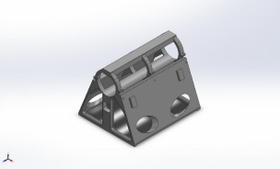
Description.
The goal of the simulation is to model the pressure distribution caused by the incoming current, which has a maximum force per area output of 1027N/m^2.
From the applied pressure distribution, stress and strain at the hinges and walls have been measured.
Simulation of Chassis Prototype Pressure Distribution
Date: Sunday, February 22, 2026
Designer: Joseph Harb
Study name: Pressure Distribution
Analysis type: Static
Table of Contents
Description .......................................... 1 Assumptions......................................... 2 Model Information ................................. 3 Study Properties.................................... 4 Units ................................................. 5 Material Properties ................................ 6 Loads and Fixtures ................................. 7 Connector Definitions ............................. 7
Interaction Information ...Error! Bookmark not defined.
Mesh information................................... 8 Sensor Details......................................11 Resultant Forces ..................................12 Beams...............................................12 Study Results ......................................13 Conclusion..........................................15
Analyzed with SOLIDWORKS Simulation Simulation of Chassis Prototype (400 mm fixed) 1
MATE ROV - OCEANUS
2/22/2026
Assumptions
Comments:
Assume that the current acts exactly perpendicular to the surface. This models an overestimation of the stress, and the real effects will not be as exaggerated.
Although the real current varies and is time dependent, this static analysis models the maximum possibly deformity resulting from the current itself.
Analyzed with SOLIDWORKS Simulation Simulation of Chassis Prototype (400 mm fixed) 2
MATE ROV - OCEANUS
2/22/2026
Model Information
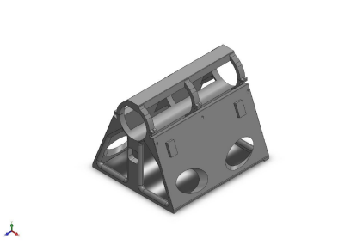Model name: Chassis Prototype (400 mm fixed)
Current Configuration: Default
Solid Bodies
Document Name and
Reference Treated As Volumetric Properties Document Path/Date Modified
Force Applied to Bodies
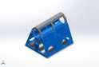Solid Body Fixture
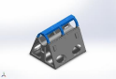Solid Body
Mass:3.852 kg
Volume:0.003852 m^3 Density:999.999 kg/m^3 Weight:37.7496 N
Mass:0.588369 kg
Volume:0.000588369 m^3 Density:1,000 kg/m^3 Weight:5.76602 N
C:\Users\josep\OneDrive - Texas A&M
University\MATE
ROV\Final Assembly (20 20 26)\Chassis Prototype (400 mm fixed).SLDPRT Feb 22 00:08:46 2026
C:\Users\josep\OneDrive - Texas A&M
University\MATE
ROV\Final Assembly (20 20 26)\Chassis Prototype (400 mm fixed).SLDPRT Feb 22 00:08:46 2026
Analyzed with SOLIDWORKS Simulation Simulation of Chassis Prototype (400 mm fixed) 3
MATE ROV - OCEANUS
2/22/2026
Study Properties
Study name Pressure Distribution Analysis type Static
Mesh type Solid Mesh Thermal Effect: On
Thermal option Include temperature loads Zero strain temperature 298 Kelvin
Include fluid pressure effects from SOLIDWORKS Flow Simulation
Off
Solver type Automatic
Inplane Effect: Off
Soft Spring: Off
Inertial Relief: Off
Incompatible bonding options Automatic
Contact penalty stiffness scale factor 1
Large displacement Off
Compute free body forces On
Friction Off
Use Adaptive Method: Off
Result folder SOLIDWORKS document (C:\Users\josep\OneDrive - Texas A&M University\MATE ROV\Final Assembly
(20 20 26))
Analyzed with SOLIDWORKS Simulation Simulation of Chassis Prototype (400 mm fixed) 4
MATE ROV - OCEANUS
2/22/2026
Units
Unit system: SI (MKS) Length/Displacement mm Temperature Kelvin Angular velocity Rad/sec Pressure/Stress N/m^2
Analyzed with SOLIDWORKS Simulation Simulation of Chassis Prototype (400 mm fixed) 5
MATE ROV - OCEANUS
2/22/2026
Material Properties
Model Reference Properties Components
Name: 80% PETG
Model type: Linear Elastic Isotropic
SolidBody
1(Fillet113)(Chassis
Default failure criterion:
Unknown
Prototype (400 mm fixed)), SolidBody 2(Cut
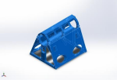
Extrude47)(Chassis Prototype
(400 mm fixed))
Curve Data:N/A
Comments:
PETG 80% Infill,
Yield strength: 2e+07 N/m^2 Tensile strength: 2.3e+07 N/m^2 Elastic modulus: 1.7e+09 N/m^2 Poisson's ratio: 0.35
Mass density: 1,000 kg/m^3
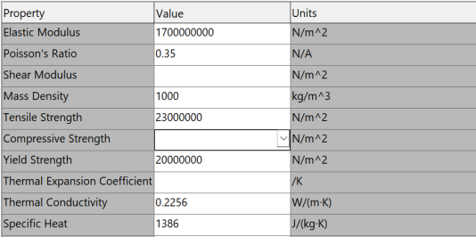Analyzed with SOLIDWORKS Simulation Simulation of Chassis Prototype (400 mm fixed) 6
MATE ROV - OCEANUS
2/22/2026
Loads and Fixtures
Main Fixtures Fixture Image Fixture Details
Entities: 4 edge(s),
77 face(s)
Type: Fixed
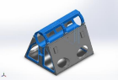
Electronics
Enclosure Fixed Resultant Forces
Geometry

Components | X | Y | Z | Resultant
Reaction force(N) | -0.00400313 | 56.9111 | -0.018106 | 56.9111
Reaction Moment(N.m) | 0 | 0 | 0 | 0

Side Walls Load Image Load Details
Entities: 2 face(s)
Type: Normal to
selected
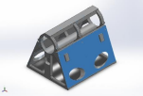
Pressure on
Both Faces
Connector Definitions No Data
face
Value: 1,027
Units: N/m^2
Phase Angle: 0
Units: deg
Analyzed with SOLIDWORKS Simulation Simulation of Chassis Prototype (400 mm fixed) 7
MATE ROV - OCEANUS
2/22/2026
Mesh information
Mesh type Solid Mesh
Mesher Used: Blended curvature-based mesh Jacobian points for High quality mesh 16 Points
Maximum element size 30.4222 mm Minimum element size 1.52111 mm Mesh Quality High
Mesh information - Details
Total Nodes 160252
Total Elements 93827
Maximum Aspect Ratio 754.7
% of elements with Aspect Ratio < 3 96.8
Percentage of elements with Aspect Ratio > 10 0.439
Percentage of distorted elements 0
Time to complete mesh(hh;mm;ss): 00:00:08
Computer name: JOSEPHHARB
Analyzed with SOLIDWORKS Simulation Simulation of Chassis Prototype (400 mm fixed) 8
MATE ROV - OCEANUS
2/22/2026
Mesh Quality Plots
Comments: The mesh quality is rated high, corresponding to an accurate simulation. The highest aspect ratios are located within the electronics enclosure, which has been modeled as a fixture, and does not interfere with the results of the simulation itself.
Name Type Min Max Mesh Density Mesh - - Chassis Prototype (400 mm fixed)-Pressure Distribution-Quality-Quality1
Analyzed with SOLIDWORKS Simulation Simulation of Chassis Prototype (400 mm fixed) 9
MATE ROV - OCEANUS
2/22/2026
Name Type Min Max
_{Mesh Quality Aspect Ratio} 1.025e+00 Element: 21244
7.547e+02
Element: 50223
Chassis Prototype (400 mm fixed)-Pressure Distribution-Quality-Quality2
Analyzed with SOLIDWORKS Simulation Simulation of Chassis Prototype (400 mm fixed) 10
MATE ROV - OCEANUS
2/22/2026
Sensor Details
Mesh Details:
Study name: Pressure Distribution (-Default-) Mesh type: Solid Mesh
Mesher Used: Blended curvature-based mesh Jacobian points for High quality mesh: 16 points Max Element Size: 30.4222 mm
Min Element Size: 1.52111 mm
Mesh quality: High
Total nodes: 160252
Total elements: 93827
Maximum Aspect Ratio : 754.7
Percentage of elements\with Aspect Ratio < 3 : 96.8 Percentage of elements\with Aspect Ratio > 10 : 0.439 Percentage of distorted elements : 0
Number of distorted elements:0
Reuse mesh for identical bodies: Off
Number of bodies that have reused mesh:0 Time to complete mesh(hh;mm;ss): 00:00:08 ---------------------------------
Analyzed with SOLIDWORKS Simulation Simulation of Chassis Prototype (400 mm fixed) 11
MATE ROV - OCEANUS
2/22/2026
Resultant Forces
Reaction forces
Selection set Units Sum X Sum Y Sum Z Resultant Entire Model N -0.00400313 56.9111 -0.018106 56.9111
Reaction Moments
Selection set Units Sum X Sum Y Sum Z Resultant Entire Model N.m 0 0 0 0
Free body forces
Selection set Units Sum X Sum Y Sum Z Resultant Entire Model N -0.241517 -0.0393057 0.0940476 0.262145
Free body moments
Selection set Units Sum X Sum Y Sum Z Resultant Entire Model N.m 0 0 0 1e-33
Beams
No Data
Analyzed with SOLIDWORKS Simulation Simulation of Chassis Prototype (400 mm fixed) 12
MATE ROV - OCEANUS
2/22/2026
Study Results
Name Type Min Max
Stress1 VON: von Mises Stress 0.000e+00N/m^2 Node: 119372
9.848e+05N/m^2 Node: 105141
Chassis Prototype (400 mm fixed)-Pressure Distribution-Stress-Stress1
Analyzed with SOLIDWORKS Simulation Simulation of Chassis Prototype (400 mm fixed) 13
MATE ROV - OCEANUS
2/22/2026
Name Type Min Max
Displacement1 URES: Resultant Displacement 0.000e+00mm Node: 10
5.891e-02mm Node: 116058
Chassis Prototype (400 mm fixed)-Pressure Distribution-Displacement-Displacement1
Analyzed with SOLIDWORKS Simulation Simulation of Chassis Prototype (400 mm fixed) 14
MATE ROV - OCEANUS
2/22/2026
Name Type Min Max
Strain1 ESTRN: Equivalent Strain 0.000e+00 Element: 70316
2.974e-04
Element: 15269
Chassis Prototype (400 mm fixed)-Pressure Distribution-Strain-Strain1
Conclusion
The deformation of the body is extremely exaggerated to emphasize effects.
The maximum displacement of the entire body was 0.05891 mm, which is negligible for our purposes.
The main thing to take away from this simulation is that the geometry connecting the electronics enclosure to the chassis will not deform or break from external pressure to the walls of the chassis.
The thickness of the walls themselves are adequate and will not deform against the provided current.
Analyzed with SOLIDWORKS Simulation Simulation of Chassis Prototype (400 mm fixed) 15

